RED WINE AND BALSAMIC SALAD DRESSING
Ingredients:
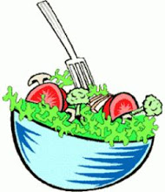
2 TBS Olive oil
2 TBS Red wine vinegar
2 TBS White or Regular Balsamic vinegar
2 TBS Water
½ TSP Red pepper flakes
1/8 TSP Garlic powder or finely chopped garlic
1/8 TSP Black pepper
1/8 TSP Onion powder or finely chopped onion
Pinch of Salt (optional)

Mix all ingredients together
Tip: Use a Mason jar and shake ingredients
All spices are optional and to taste

Makes 2 servings (each serving 1 gram of carbs)

